**MAKERERE     UNIVERSITY**

**COLLEGE OF COMPUTING AND INFORMATICS**

**SYSTEMS**

**DEPARTMENT OF NETWORKS.**

**GROUP7**

**SOFTWARE REQUIREMENT**

**SPECIFICATION (SRS)**

*GROUP7 MEMBERS:*

|  |  |  |  |
| --- | --- | --- | --- |
| **NO** | **NAMES** | **Reg No** | **Stud No** |
| 1 | Niwandiinda John Martin | 17/U/9138/PS | 217010696 |
| 2 | Miiro Henry | 17/U/6112/EVE | 217009093 |
| 3 | Onyang Joshua | 17/U/9702/PS | 217016961 |
| 4 | Odongo Abraham | 17/ U/9494/PS | 217002258 |

**SOFTWARE REQUIREMENT SPECIFICATION FOR HOUSE PRICE PREDICTION SYSTEM.**

This system will be used by the three categories of people that is data analyst, customer (buyer) and the seller as shown in the use case below.

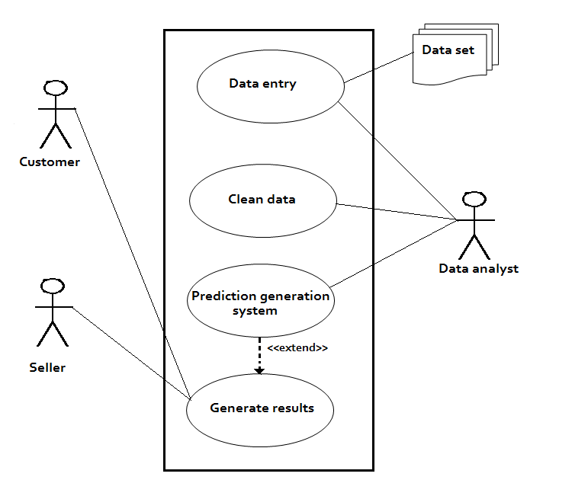

*The breakdown of the use case.*

**Data analyst.**

The data analyst enters the data to the system by loading the csv file from the dataset folder. He/she cleans and prepares it to make it ready for the entry in the prediction generation system. He enters the data into the prediction entry system which produces the results in form of predictions. Below is a diagram that summaries all this.

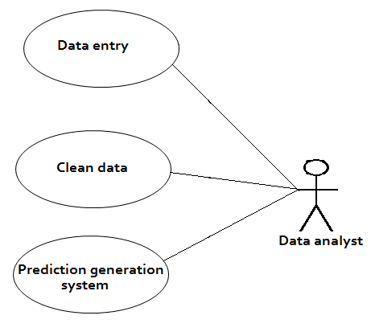

**Customer.**

The customer checks the result/prediction and determines whether to buy a house now or in future according to whether the price will increase or reduce.

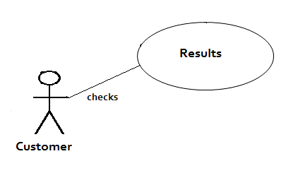

**The seller.**

The seller checks the prediction and determines the factors that lead to an increase in house prices. These factors may include renovation, bed space, location, living space, grade, condition. stc.

